How to RSVP for Games and practices

- Log in with the username and password you used to register.
- Click on the “Visit Team Page” button.
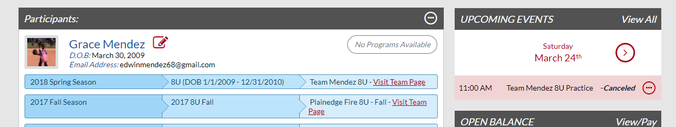
- Click on the Calendar Tab in the middle of the page
- Click on “View Event” for the event that you event to RSVP for.
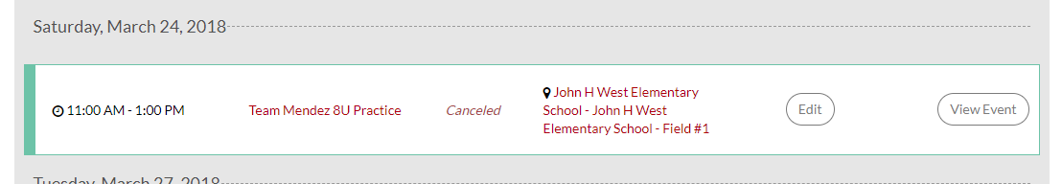
- Find your daughter on the righthand side under the column that says RSVP and click either Yes or No.
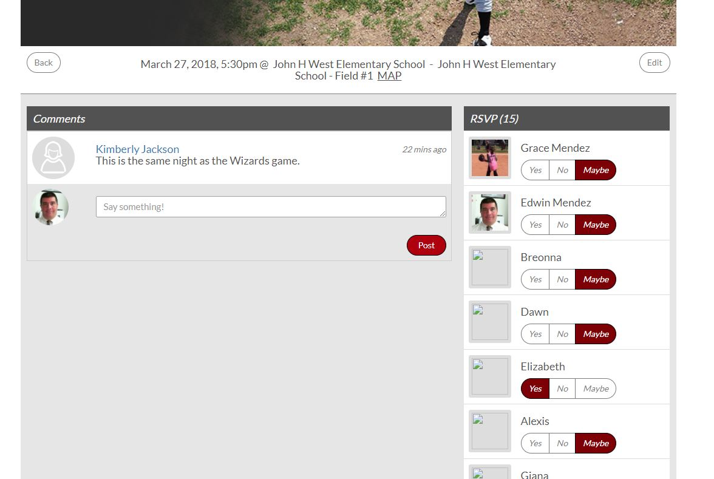
- Please do this for all practices and especially for games. It is critical for you manager to know how many girls are coming. Most managers will make the lineup and fielding charts before the game.

